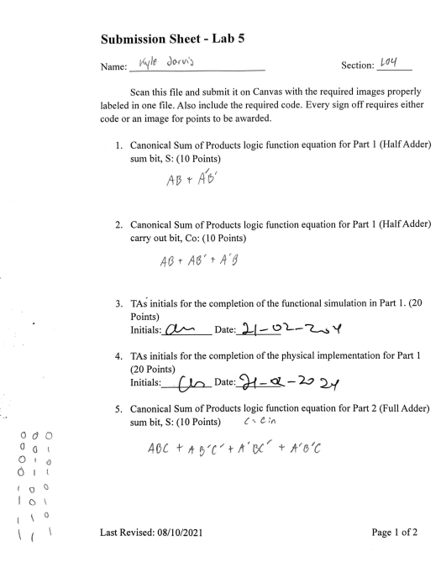

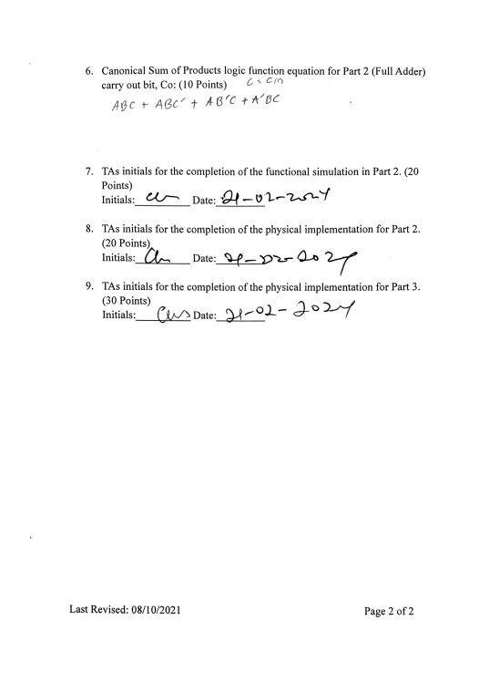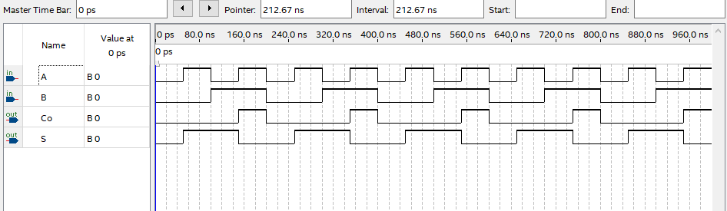

Lab 5 Part 1 Functional Simulation

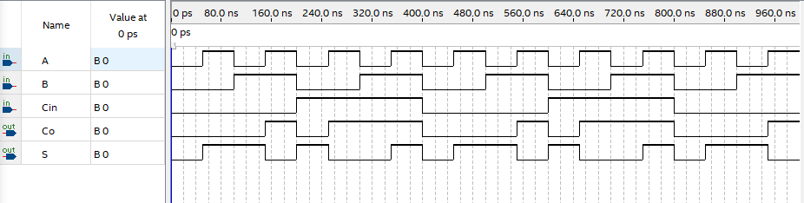

Lab 5 Part 2 Functional Simulation